Payment Terms Master (Master)

1. This master is use for Payment Terms description creation.
Navigations : Master --> System Master --> Payment Terms Master.

Please see the below screen 1,2 & 3 for more understanding.

Screen (1)
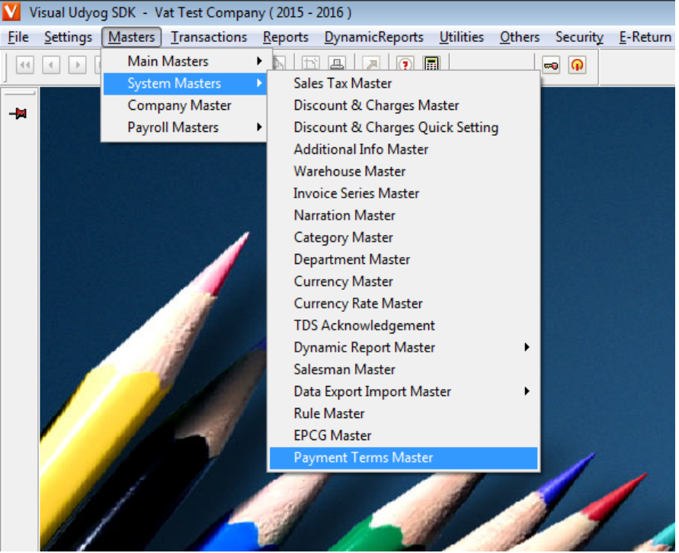
Screen (2)
In this text box user can add terms caption (a short name)
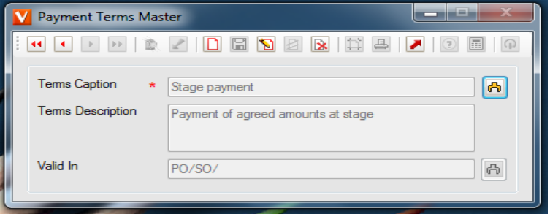
Screen (3)
From selecting this button user can select multiple transactions entry type at one time which you want to use for your Payment Terms
as shown in sceen 3
In this text box user can add Payment Terms full description but this should not exceed more than 250 characters.
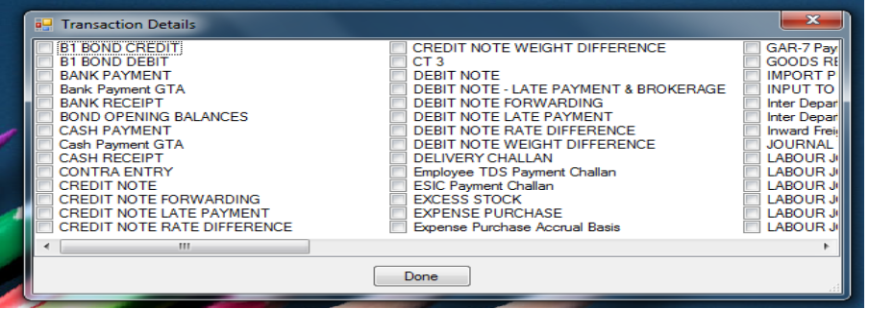

Payment Terms Master (Transactions Setting)

2. The screen is for transaction setting to activate the Payment Terms button in the selected transaction.

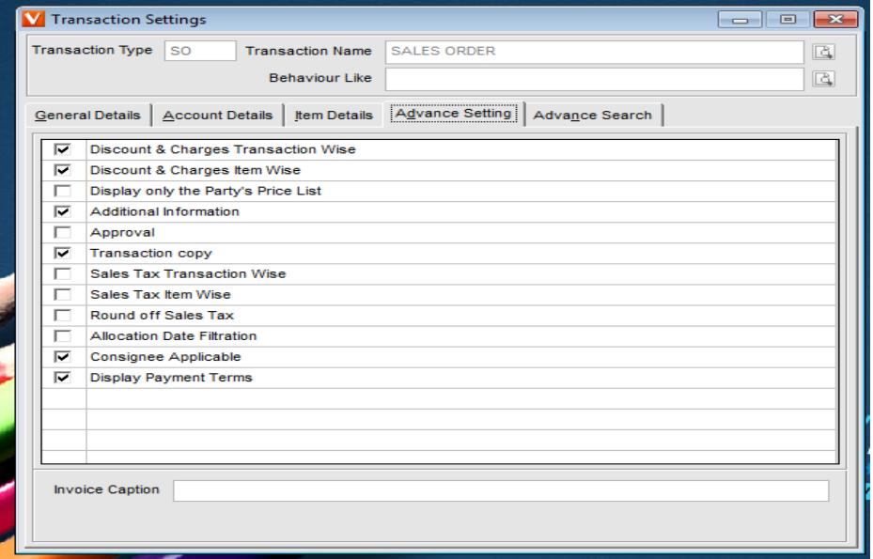
To be activated payment terms button in the selected transaction
“Display Payment Terms “ should be checked
Selected Transaction
Payment Terms Master (Transactions Entry)

3. This is transaction screen for selected transaction in transaction setting.
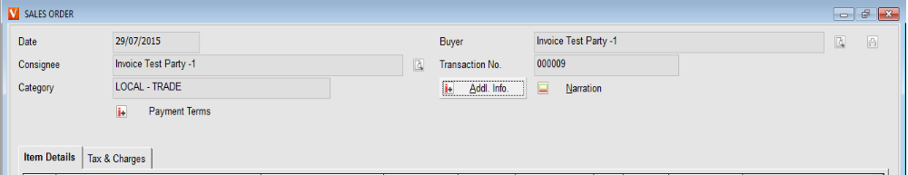
This button will automatic activate after the transaction setting is done.
4. After click on the Payments terms button the below windows will come

- All created payment terms description will come.
- For the selected transaction all description will be checked automaticlly which was selected Valid in while master creation .
- User can not select more then 25 terms for the current transaction.
- Payment terms description is editable on run time, only for the current transaction (The actual master will not be changed).
- Payment terms description should not exceed more than 250 characters .

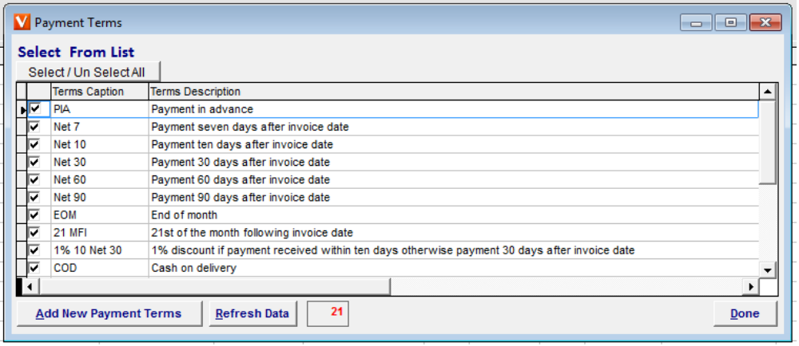
Count for terms
By click on this button you can add new payments terms in master.
By click on this button master data will be refreshed again
By click on this button user can select / un select all terms
By click on this button window will be closed
Payment terms description

